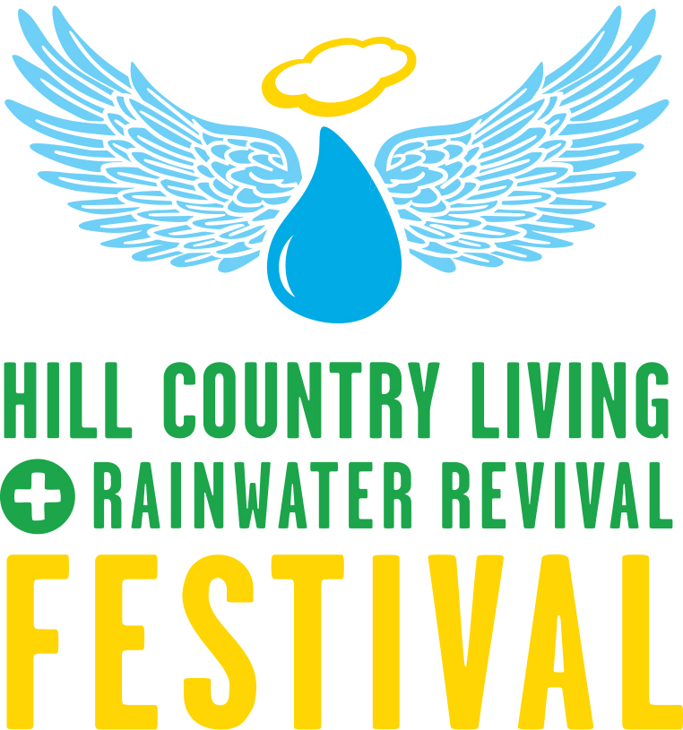

**SPEAKERS’ SCHEDULE | UPSTAIRS STAGE**

**Master of Ceremonies: Cliff Kaplan, HCA Program Manager**

**10:30 am** **Dos and Don’t for the RWH DIYer** Chris Maxwell-Gaines

Innovative Water Solutions

**11 am** Managing Land for Wildlife Tim Milligan, Plateau Land & Wildlife Management

**11:30 am** The Beauty and Bounty of Bees Tanya Phillips, Bee Friendly Austin

**12 noon** Message from a Dark Night Sky Cindy Luongo Cassidy, International Dark Sky Assn.

**12:30 pm** OPEN

**Master of Ceremonies: Jeannie Ralston, Next Tribe**

**1:00 pm** Rainwater Harvesting 101 Alan Rossing, Lakota

**1:30 pm**  Buying & Selling Rural Land Craig Bowen, Plateau Land Group

**2 pm** Be Native to Your Place Gene Stalzer, Native American Seed

**2:30 pm** Building Beautiful and Green (speaker tbd) MiroRivera Architects

**3 pm** Live it, don’t lip it…and lavender too! Jeannie Ralston, Next Tribe

**3:30pm** TBD