**Permeable Paving**

Permeable Paving is paving that is porous and allows for water infiltration. It is used to manage stormwater in a way that is more environmentally sensitive than standard paving. There are several types of permeable paving, including: pervious concrete, porous asphalt, and permeable interlocking concrete pavers (PICP)[1].

*How pervious pavement works....*

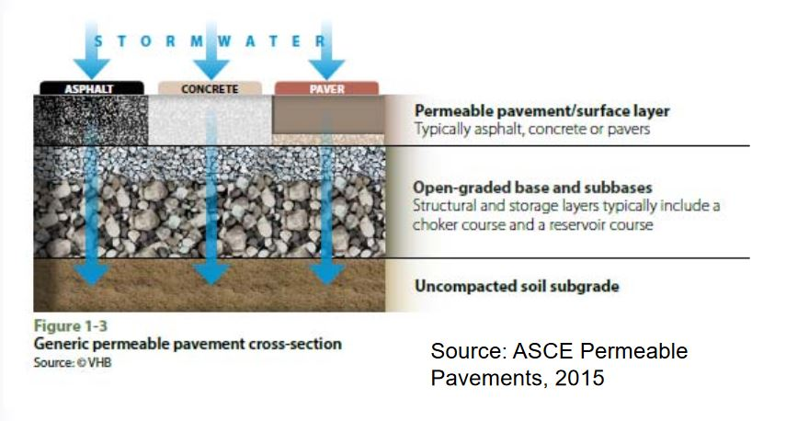

*Above shown is a generic example of a pervious pavement system[2]*

There are many benefits to permeable paving, listed below.

Permeable Paving:

* Enables stormwater to be filtered before reaching groundwater
* Contributes to groundwater recharge
* Reduces the amount of untreated stormwater reaching rivers and lakes, which reduces pollutants and stream bank erosion[3]
* Functions such that rainwater is less likely to pool than on standard pavement, increasing pedestrian safety
* Stays cooler than standard paving at summer temperatures, thus reducing urban heat island effect[4]
* Reduces “summer runnoff temperatures which can be important in watersheds with sensitive cold-water fish populations”[5] [6]
* Can offer visual beauty with options for color tinting[7]

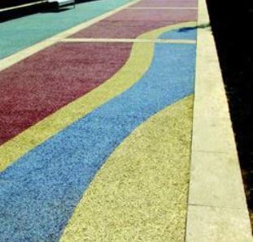 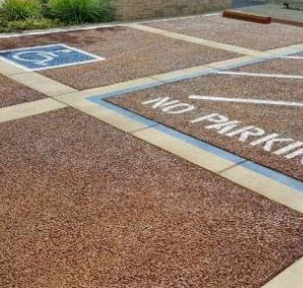

*Above shown are examples of decorative colored pervious concrete*.[8] [9]

* Helps projects reach LEED certification
* “Eliminates costs for retention basins, curbs, gutters, and other water collection installations”[10]
* Can be used around urban trees to help tree roots receive water

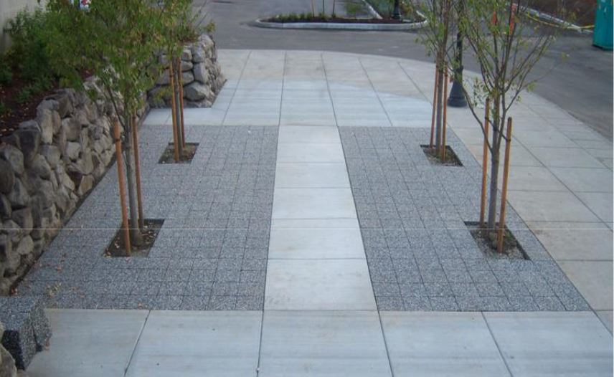

*The image above shows pervious paving blocks inserted around urban trees.[11]*

Permeable paving is recommended for sidewalks, parking lots, residential driveways, areas with low traffic volumes and low truck volumes, areas with low speeds, alleys, overflow parking, and parking stalls. Residential collector roads are suitable.

Due to the filtering capacity of permeable paving, there are situations in which permeable paving is not the right solution. For instance, permeable paving is not recommended for sites with karst formations because the stormwater will not get adequately filtered before reaching the groundwater.[12]

Additionally, permeable paving is not suitable for sites with poor soil drainage, sites with high levels of wind-blown dust and debris, slopes over 5%[13] or sites “where concentrations of oils and grease, heavy metals and toxic chemicals are likely to be significantly higher than in typical stormwater runoff.”[14]

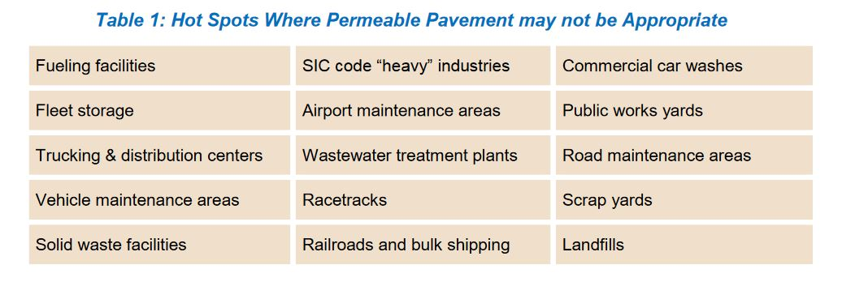

The chart[15] above shows places of high toxin concentrations that are not suitable for permeable paving.

**Ordinances:**

*Township of Lower Makefield, PA*

Link from computer

*City of Austin*

<https://library.municode.com/tx/austin/codes/environmental_criteria_manual?nodeId=S1WAQUMA_1.6.0DEGUWAQUCO_1.6.7GRSTWAQUIN_EPOPA>

*College Station, TX, section F.c.2.*

Link from computer

**Best Practices**

***Provide or disseminate design standards***

Provide design standard specifications to which design companies are expected to meet.

Section 3 in the Austin Ordinance (linked above) shows an example of design guildelines. Section 4 of the same ordinance also mandates that the builder prove specialized competence through a certificate from one of a number of recogonized porous pavement industry associations.

***Determine a managment practice, maintenance schedule, and maintenance checklists***

Pervious pavement requires a maintenance practices of regular sweeping to remove debris and dust that falls into the porous areas of the pavement. Owners of permeable paving need to be made aware of maintance expectations to ensure the long-term functioning of the paving. Below are some articles regarding best maintenance practices for pervious pavement. Both Austin and Makefield Township ordinances provide specific maintenance language.

*Operation and Maintenance of Permeable Pavement* (examples of maintenance checklists are included on this webpage)

<https://stormwater.pca.state.mn.us/index.php/Operation_and_maintenance_of_permeable_pavement>

*Pervious Concrete Pavement Maintenance and Operations Guide*

<https://www.perviouspavement.org/downloads/pervious_maintenance_operations_guide.pdf>

An Overview on Porous Pavement Surfaces and Current Sweeping Best Practices.

<http://www.worldsweeper.com/Street/BestPractices/TrinkausPorousPavement6.16.html>

**Other helpful links:**

*Here’s What You Should Know about Permeable Pavers*

<https://www.totallandscapecare.com/business-best-practices/how-tosustainability-what-you-should-know-about-permeable-pavers/>

*North Carolina.gov Design manual*

<https://files.nc.gov/ncdeq/Energy%20Mineral%20and%20Land%20Resources/Stormwater/BMP%20Manual/C-5%20%20Permeable%20Pavement%2004-06-17.pdf>

*Minnesota design criteria for pervious pavement*

<https://stormwater.pca.state.mn.us/index.php/Design_criteria_for_permeable_pavement>

1. Minnesota Stormwater Manual: Types of Permeable Pavement. <https://stormwater.pca.state.mn.us/index.php?title=Types_of_permeable_pavement>
2. Pervious Pavement for Stormwater Control: Application, Selection, and Design Considerations. <https://www.flowstobay.org/sites/default/files/3-SMCWPPP-Intro%20to%20Pervious%20Pavement.pdf>
3. Permeable Pavement. Winnebago County, IL. <https://wincoil.us/departments/highway-department/highway-programs-information/stormwater-management/best-practices-resources/permeable-pavement/>
4. Minnesota Stormwater Manual: Additional Conserations for Permeable Paving <https://stormwater.pca.state.mn.us/index.php?title=Additional_considerations_for_permeable_pavement>
5. *Ibid.*
6. https://www.ncbi.nlm.nih.gov/pmc/articles/PMC1257665/
7. Decorative Pervious Concrete <https://www.concreteconstruction.net/products/decorative-concrete-surfaces/decorative-pervious-concrete>

   _o
8. Left image from: *Ibid.*
9. Right image from: Pervious Pavement for Stormwater Control: Application, Selection, and Design Considerations. <https://www.flowstobay.org/sites/default/files/3-SMCWPPP-Intro%20to%20Pervious%20Pavement.pdf>
10. Green Building Alliance: Permeable Pavement

    <https://www.go-gba.org/resources/green-building-methods/permeable-pavements/>
11. Pervious Pavement Ordinance: Lower Makefield Township Environmental Advisory Council

    <https://www.lmt.org/wp-content/uploads/2015/01/EAC-Pervious_Presentation.pdf>
12. Minnesota Stormwater Manual: Design Criteria for Permeable Pavement. <https://stormwater.pca.state.mn.us/index.php/Design_criteria_for_permeable_pavement>
13. Pervious Pavement Ordinance: Lower Makefield Township Environmental Advisory Council: <https://www.lmt.org/wp-content/uploads/2015/01/EAC-Pervious_Presentation.pdf>
14. NCDEQ Stormwater Design Manual: C-5. Permeable Paving

    <https://files.nc.gov/ncdeq/Energy%20Mineral%20and%20Land%20Resources/Stormwater/BMP%20Manual/C-5%20%20Permeable%20Pavement%2004-06-17.pdf>
15. *Ibid.*