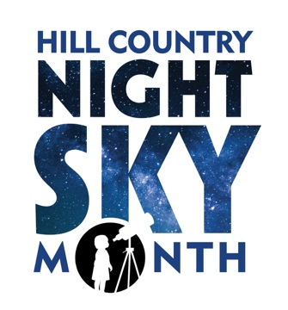

MEDIA ADVISORY
Released [DATE]

October is Hill Country Night Sky Month

Hill Country Night Sky Month is a celebration of one of our region’s most dazzling features — the star-filled night sky — and a time to recognize the many ways Hill Country communities are working to preserve it.

Hill Country Alliance (HCA) is joined by partners and night sky champions across the region for a month of virtual events, activities, artist expressions, games, competitions, proclamations and other ways to expand the joys and benefits of dark night skies – all Covid-safe and health aware.

[Name of Org] to Celebrate with [a Virtual Event]

WHO
WHAT
WHEN
WHERE/HOW
Description:

Event Partners:

Media Contact: [name, phone, email]

HCA’s web portal, NightSkyMonth.com, is a clearinghouse for information, inspiration and events occurring throughout October 2020.

Hill Country Night Sky Month is made possible by these sponsors:
[name sponsors]

