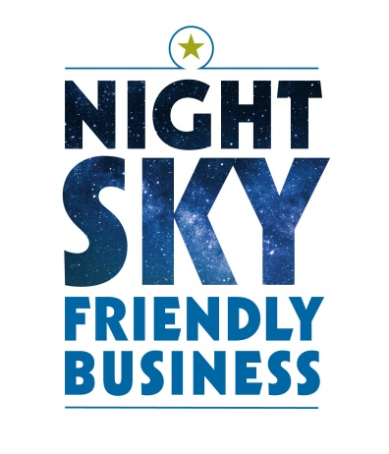**{Your Organization’s name or Geographic Region} Night Sky Friendly Business Recognition Program**

**A program sponsored by {Your Organization’s Name} and {Your Local Chamber or Partner}, endorsed by the Hill Country Alliance**

**FACT SHEET**

***WHAT IS NIGHT SKY FRIENDLY LIGHTING?***

* Night Sky Friendly Lighting is outdoor lighting that does not shine into the sky, onto neighbors’ property, or into the eyes of neighbors, patrons, or others passing by.
* It is outdoor lighting that is used only when and where it is needed, at a brightness appropriate to the task, with a preference for amber light rather than white or blue light.

***WHY IS NIGHT SKY FRIENDLY LIGHTING IMPORTANT?***

**Night Sky Friendly Lighting offers several benefits to you and to our community.**

* **Heritage:** Night Sky Friendly Lighting helps preserve the starry sky, a natural wonder that inspires our children, draws visitors from across the state and beyond, and is an iconic part of our heritage deep in the heart of Texas.
* **Business:** As long as we do not allow the night skies to be obscured by our outdoor lighting, sky-gazing will be good year-round in our region, an important draw for tourists, allowing the local economy to be less dependent on river tourism.
* **Savings:** Light that shines into the sky or onto a neighbor’s property is wasted light. So is light that shines more brightly than it needs to, or at times when it is not needed. Wasted light is wasted electricity and wasted money. Savings from switching to Night Sky Friendly Lighting are significant in most cases.
* **Health:** Light pollution is known to affect human health by negatively impacting melatonin production in our bodies, affecting our sleep, which in turn impacts our metabolisms, our mental health, and other facets of our well-being. These harms are recognized by the American Medical Association.
* **Safety:** Light that is needlessly bright diminishes our ability to see at night, increasing the chance of auto-accidents and decreasing our ability to scan an area for intruders, wildlife, or other concerns.
* **Stewardship:** Light at night is known to have negative effects on wildlife, including fireflies, bats, birds, and other creatures, with effects that can ripple throughout the ecosystem and impact economic development based on these natural resources.

***HOW DOES MY BUSINESS PARTICIPATE?***

***To earn recognition, your business’s lighting must meet the following criteria:***

* All outdoor lighting on the premises is shielded and aimed downward so that no light trespasses beyond the business property boundary or above the horizontal plane into the sky. Lighting is directed only where it is needed for the task at hand.
* Lighting is not so bright as to cause glare or to reduce visibility in unlit areas.
* The color of outdoor lighting is amber or warm white versus bright white or blue. Lighting with a color temperature of less than or equal to 3000 Kelvin is ideal.
* Lights are installed with motion detectors or timers when practical in order to prevent lights from being needlessly on all night. Outdoor lighting is extinguished after business hours. At gas stations, if pumps remain operational after the store has closed, it is appropriate to light under the canopy.
* Request an inspection of your property by emailing your company name and contact information to {Your Organization’s Email Address}.
* Allow for an annual inspection to ensure compliance with the guidelines. Any future outdoor lighting installed on your premises will be Night Sky-Friendly.

***HOW WILL MY BUSINESS BE RECOGNIZED?***

***A business or organization that meets the criteria listed above receives recognition as a Night Sky Friendly Business with:***

* A Certificate of Merit presented by {Your Local Chamber of Commerce or Partner} and {Your Organization’s Name} for display inside your business.
* A small window decal display to announce to customers your recognition as a Night Sky Friendly business
* The right to use the Night Sky Friendly Business logo in your advertising, including on your website
* A link to your business’s website on the websites of the {Your Chamber of Commerce or Partner}, {Your Organization’s Name}, and the Hill Country Alliance; (businesses without websites will be listed as well)
* Special recognition at any Night Sky events held the {Your Chamber of Commerce or Partner}, {Your Organization’s Name}
* Possible publicity in local media

To learn about which cities, counties and organizations that have passed Night Sky Resolutions, visit: <https://www.hillcountryalliance.org/nightskydesignations>

For more information, visit www.hillcountrynightskies.org