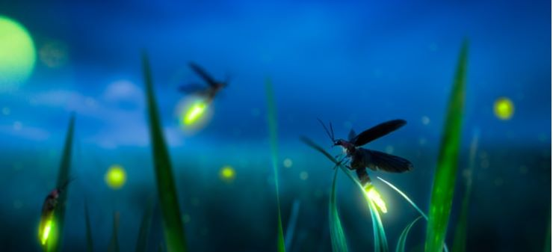
Hello Neighbor!
The recent virus has reminded us about the great outdoors. From our home at __________, we have watched so many more walkers, runners, bikers, skaters and dogs than we have watched for the almost 30 years that we have lived at our little house. Also, although a little chilly, it has been such a wonderful Spring. So green. So many flowers! And so quiet.
Recently, I volunteered to become a delegate for the International Dark-Sky Association (IDA). Our days have a day and a night. During the night, we should be able to more see stars and planets. We should be able to see our magnificent Milky Way. Unfortunately, because of light pollution, we can see with the naked eye only 31 of the tens of thousands of stars that we should be able to see. Only decades ago, before the flood of outdoor lights, we could see thousands of stars. We could see meteor showers. Vincent van Gogh said while painting one of his many starry night masterpieces; “It often seems to me that the night is much more alive and richly colored than the day.”
A couple weeks ago, I read on the internet the attached article on Firefly Conservation. Like the stars and planets, we also have fewer fireflies, also known as lightning bugs. After I became a delegate, I learned how much outdoor lighting affects not just the fireflies, but our night-time pollinators, like the moths. The moths are attracted to our bright white outdoor lights. Instead of pollinating our flowers, fruits and vegetables, they circle the lights and tire and die. Also, during Spring and Fall, many birds that migrate and travel to or through Glen Ellyn become distracted by the increasingly bright and unshielded LED night lights. Birds migrate a night. So many get lost in the bright lights. Some strike buildings. Too many birds and insects die because of night light pollution.
So, as we move into Summer when we bring out the lawn chairs, light a little backyard fire, look up at the sky and watch and catch a few fireflies, I’d like to challenge our short street (maybe one of the shortest in ________) to manage the intensity and duration of our outdoor lights/lighting. While I understand that many of us cannot afford to replace our outdoor fixtures with fixtures that shield the light from shining up and out from our homes and garages, we can install LED bulbs that remove the bright blue light. We can install bulbs that are not more than 2700 Kelvin and not more than 800 lumens. These bulbs are inexpensive and are available at all local hardware stores. Also, and maybe more importantly, we can turn off our outdoor lights after 10pm or after whatever time makes us most comfortable. We can use motion sensors.
Hopefully, we can have a block party again this summer. Although we may have to keep our distance and wear a mask, we can have a fire or two in our street, turn off the lights and look up to the sky together. Maybe we can also enjoy a few more fireflies. If any of you are interested, please stop to chat or email me at___________. Also, please visit the IDA website; www.darksky.org or the IDA Facebook or Instagram pages. Let’s Go Dark!
Your neighbor, Name
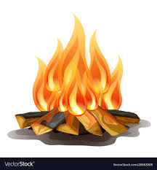
IDA Delegate

